Connect With Us…Directly From Your Smart Phone!

Our software provider Eclipse offers a great application that can be downloaded to your smart phone and have your account authorization established to be able to do a variety of functions at any time….

- Review Your Account

- Review Orders

- Check Inventory & Pricing

- Place Orders

Here is a quick sample of the new product called Innovo OE Touch!
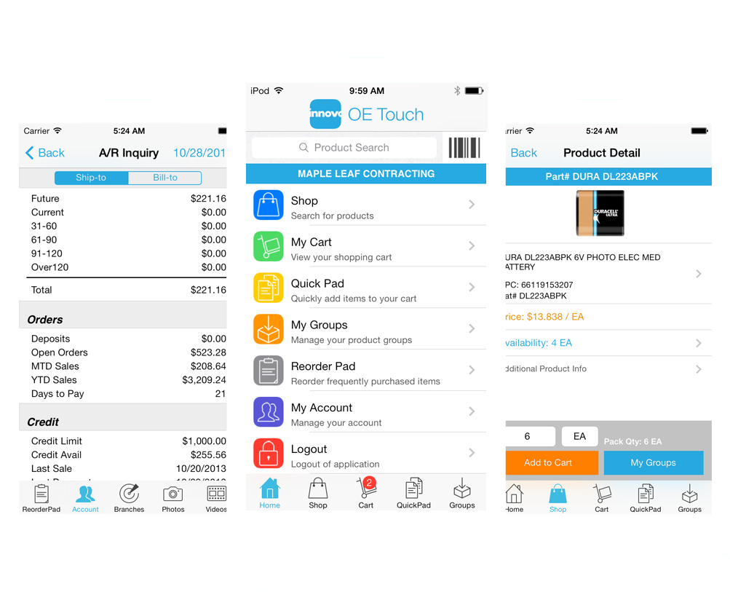
See the next page for enrollment into this exciting new product…..

Innovo OE Touch
Program Details & Enrollment Form

Program Details

1. Once enrolled, we can set this application up on many of your employees at your discretion and approval.

2. There is no fee for the enrollment and use of our program, but we expect a reasonable level of support in your continual purchases from TPG.

3. Customers must sign the following agreement form.

4. There will be no expiration of your use based on a set term, but rather will be applicable to your continued purchase commitment.

5. All orders will default to the Bid Status. You need to note in the Shipping Instructions which bids are actually orders and you must provide an accurate ship date and instructions as to delivery or customer pick-up. TPG will be checking these orders every half hour.

Enrollment & Agreement

By signing below in the space provided, you acknowledge and agree to the following conditions:

1. Sign up must be by a principle of the company. You must provide in writing the employees allowed to use this application and must also provide in writing when you want to discontinue the authorization of any given employee and you agree to pay for all orders placed by people you authorized to use TPG OE Touch (Innovo) and/or TPG Web Order Entry.

2. The Portland Group and Innovo are not responsible for any aspect of the operation of your phone and/or the interaction with this application.

3. You must take care in entering your orders and accept full responsibility for any handling charges that may occur on orders mistakenly entered by your company and processed by TPG.

4. The Portland Group reserves the right to discontinue this service at any time for any customer at our own discretion.

___________________________________ __________________________________________
Signature Print Name/Title

Date: ______________________________ 30 Day Trial Option: ____Yes ____No

Innovo OE Touch
Customer’s Employee Information Form

In order to sign you up for OE Touch we will need the name, email address and phone number of each person you want to have the app as well as whether or not they should have access to the full account info including credit limits.

Company Name |  | City |  | Main Company Phone
Name |  | Email Address |  | Phone |  | Account Inquiry Y/N

Name |  | Email Address |  | Phone |  | Account Inquiry Y/N
Name |  | Email Address |  | Phone |  | Account Inquiry Y/N

Name |  | Email Address |  | Phone |  | Account Inquiry Y/N
Name |  | Email Address |  | Phone |  | Account Inquiry Y/N

Name |  | Email Address |  | Phone |  | Account Inquiry Y/N

